附件1 摘要提交模板
Paper abstract submission

Title of Paper : xxxxxxxxxxxxxxxxxxxxxx

Title (Mr/Ms/Dr/Prof):

Names of Authors(First Name Family Name) :
XXXXXxxxxxxx* and XXXXXXXXX**

Organizations : * XX University, ** XX Maritime University

Address of First Author :
e.g.) Busan Port International Exhibition & Convention Center (BPEX)
5th Floor, 206, Chungjang-daero, Dong-gu, Busan 48751, Republic of Korea

E-mail address of First Author : e.g.) delta@gmail.com

Topics of the Symposium:
Please choose your paper’s topic and check to the box.
Topics of the Symposium
□Marine Safety and Security
□Vessel Traffic Management
□Shipping Policy
□Maritime Education and Training
□Modern Marine Engineering Management
□Thermal Energy and Power Engineering on Ships
□Green Ship Technology
□Maritime Intelligent Transportation System
□Ship Virtual Reality Technology and Simulation
□Electronics and Information Technologies in Maritime Industry
□Special Ships Operating and Its Supervision
□Other Related Topics

Keywords : xxxxxx, Xxxxx, Yyyyy, Zzzzz, Wwwww( more than 4 words)

Abstract: Xxxxx xxxxx,xxxxxx xxxxx xxxxx xxxxx xxxxx xxxxx xxxxx xxxxx xxxxx xxxxx xxxxx xxxxx xxxxx (400~500 words ) xxxxx xxxxx xxxxx xxxxxx xxxxxx xxxxx xxxxx xxxxx xxxxx xxxxx xxxxx xxxxx xxxxx xxxxx xxxxx

INSTRUCTION TO PAPER PREPARATION FOR FULL PAPERS
英文版全文提交格式说明和模板

1. Submission

All authors should submit the abstracts and full papers by the above deadline dates to Secretariat of ANC through the local Institute of Navigation (CIN,JIN, KINPR,).

2. Format of manuscript

(1) Paper Size: A4 paper
(2) Manuscript: Less than 10 pages including figures, tables and pictures
(3) Structure of the Manuscript
Title
Author(s)
Affiliation(s), address(es) and e-mail address(es)
Key words
Abstract
Main texture
References
(4) Heading Numbers (example)
ABSTRACT (The length of the abstract should be less than about 300 words.)
1. Introduction
2. Target Area and Database
2.1 Target Area
2.2.1 Target
2.2.2 Area
2.2 Database
3. Analyses
4. Result
References (in alphabetical order of the family name of the first author)
(5)Font and Page Layout
Font: Times New Roman
Point: Title: 14 point and bold Others: 10 point
Headings: bold
Margin: Top and bottom margins: 30 mm Left and right margins: 25 mm
Spacing: Single spaced
Column: Both single and double columns are acceptable.

(title is 14 point and bold)
(top margin is 30 mm)
The Title of the Manuscript of Asia Navigation Conference 2025

Taro FUKUOKA* and Hanako FUKUOKA**
*JIN Maritime and Ocean University, 2-1-6 Ecchuujima, Kohtoh-Ku, Tokyo 135-8533 Japan
** JIN Maritime and Ocean University, 2-1-6 Ecchuujima, Kohtoh-Ku, Tokyo 135-8533 Japan
info-anc2025@anc2025.info
(Family name in a capital letter)
Key words: navigation, science, technology, education, safety, maritime
(others are 10 point)
(left margin is 25 mm.) (right margin is 25 mm.)
ABSTRACT
Asia Navigation Conference 2025 is the international conference of navigation and maritime science, technology, education and so on. This international conference will be held from December 3-4, 2025 in Fukuoka, Japan.
The length of the ABSTRACT should be less than about 300 words.

1. Introduction
Asia Navigation Conference 2025 is the international conference of navigation and maritime science, technology, education and so on. This international conference will be held from December 3-4, 2025 in Fukuoka, Japan

2. Target and Goal of Asia Navigation Conference (Headings are bold.)
2.1 Target of Asia Navigation Conference
The local executive committee is willing to share the target of Asia Navigation Conference with any participants. The committee would like to have any requests and questions from you.

2.2 Goal of Asia Navigation Conference
The papers are kindly requested to address any of issues identified as the goals and activities of the working groups. The goal is detailed in the paper
2.2.1 WG-I (references in the texture.)
This group aims at navigation and maritime science, technology, and education to the safety and the environmental protection at sea.
2.2.2 WG-II
This group aims at the establishment of the safety management system (Navigation and Port Research, 2004) at sea.

3. Results and Discussions
The results obtained here are quite important for the navigation and maritime science, technology, education, and so on. They are same to the goal of Asia Navigation Conference.

References (in alphabetical order of the family name of the first author.)
(1)Kim Gwangyang (2000): What is the Goal of Asia Navigation Conference, Int. J. Navigation and Port Research 2(1), 120-130
(2)Korea Institute (2004): The Maritime Safety Science, Technology, and Education Group of TECHNO-OCEAN, Proceedings, TECHNO-OCEAN2000, 123-130.
(3)Navigation and Port Research (2004): The Maritime Education System in Safety Management,
J. Maritime Management, 20, 105-112.
(4)Park ,J.S.and Lee,J.W. (1988): Discussion on Asia Navigation Conference 2004, Maritime, 30, 123-129
(bottom margin is 30 mm)

Author’s Biography
The author’s biography is the last section and should not exceed 300 words.

附件3 论文排版说明
题目
作者名^{1a}，作者名^{1b}，作者名²
（1. 作者一级单位a.二级单位；b.二级单位，省 市 邮编；2. 作者详细单位，省 市 邮编）
摘 要：中文摘要400字以内，包括（1）研究的目的与问题、（2）研究方法、（3）研究结果、（4）研究结论或新发现。要用第三人称，不要使用“本人”“作者”“我们”等作为摘要陈述的主语。摘要中可以有数学式、化学式、插图、表格等,但不应含有数学式、化学式、插图、表格、参考文献等的编号,不宜使用非公知公用的符号和术语。对摘要中首次出现非公知公用的简称、外文缩略语和缩写词,应给出全称、中文翻译或解释。摘要能否准确、具体、完整地概括原文的创新之处，将直接决定论文能否被收录、阅读和引用。
（小5号黑体左缩进2字符，右缩进2字符，全角冒号）
关键词：关键词1；关键词2；关键词3

Title title
（14磅黑体居中，Times New Roman字体，第一个单词首字母大写，其余小写）
NAME Name^{1a}，NAME Name^{1b}，NAME Name²
（1a.Department；1b.Department，University，City post code，State；2.Department，University，City post code，State）
Abstract：英文摘要应是中文摘要的转译，所以只要简洁、准确地逐段将文章译出即可，时态常用一般现在时、一般过去时，少用或不用现在完成时、过去完成时、进行时态和其他复合时态。尽量使用短句，但也要避免单调和重复。英文缩略词先写全称，括号中加缩略词。外文摘要可以比中文摘要包含更多信息。
（小5号 Times New Roman黑体，左缩进2字符，右缩进2字符，冒号用全角）

Key words：keyword 1；keyword 2；keyword 3

引言中应交代清楚所论述问题的研究背景，包括国内外该领域的研究进展，针对现有方法存在的问题及本文研究的基础，本文的研究方法、手段、理论等的创新之处。不要与摘要雷同或成为摘要的注释，避免公式推导和一般性方法介绍。引言中一般不列图、表与公式。引言不编入序号。
1 标题（4号仿宋左顶格）
（数字标号加粗，加1个空格）
1.1 标题（5号黑体左顶格）
1.1.1 标题（5号楷体）
（小5号黑体）
文中列项说明先用1）2）3），下一级再用①②③，除数学式一般不用（1）（2）（3）。
论文中的缩写第一次出现时一定要注明中英文全称，文中再提及时全文统一用缩写形式。
量符号通常为单个拉丁字母或希腊字母，描述传递现象的特征数由2个字母组成，一律斜体；单位符号应用正体字母书写。量符号下角标字母表示物理量符号、坐标轴、几何图形中点面线体连续数时，一律用斜体；其他下标一律用正体。
数字的书写要规范：对于纯小数，小数点前的“0”不能省略；小数点前或后每隔3位数拉开1/4空格，而不使用千分撇。如果文中单位用英文，则文中所有单位统一用英文表示；如果文中单位用中文，则所有单位统一用中文表示。
地理坐标统一格式：29°51'.700N，122°10'.300E。
表1 叶栅主要几何参数和气动参数
Tab.1 Main geometry and aerodynamic parameters of cascade

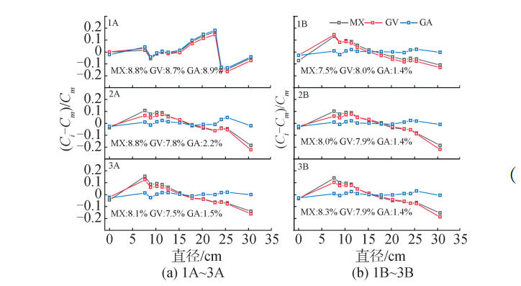
图7 反解计数率与实测计数率的比值
Fig.7 The ratio of the folding count rate to the measured count rate
数学式：
1.数学式须用公式编辑器mathtype6.0/6.5编辑，请勿使用word自带的编辑器编辑
2.数学式以在文中出现顺序依次编号，如（1）、（2）…并右对齐编号。文中提及数学式时，称为式（1）、式（2）、式（3）……
3.数学式字体为Times New Roman，10.5磅，变量为斜体，常量为正体，向量、矩阵为黑斜体，转置符号用正体。长公式在运算符号后回行。
4.量的名称或多字母缩略术语,不论正体或斜体,亦不论是否含有下标,都不应该用来代替量的符号。

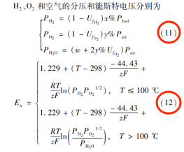
参考文献：
- 参考文献著录格式须符合《参考文献格式国家标准GB T7714-2015》，文件见投稿网站下载中心。文献作者3名以内全部列出，4名以上则列前3名，后加“等”或“et al”；中外文作者姓名书写，姓前名后，不加缩写点。
- 参考文献标题为5号黑体居中，参考文献内容为小5号宋体。参考文献中标点符号为半角。
- 中文参考文献须提供英文对照，英文后加“(in Chinese)”
- 参考文献不少于10篇。按文中出现的先后顺序编号,并著录公开发行的学术类期刊和专著（内部资料、私人通信、待发表的文章一律不引用），近5年的文献量应占50%以上。

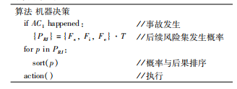
代码或伪代码：
以两条粗横线单独框出，代码字体为小五宋体
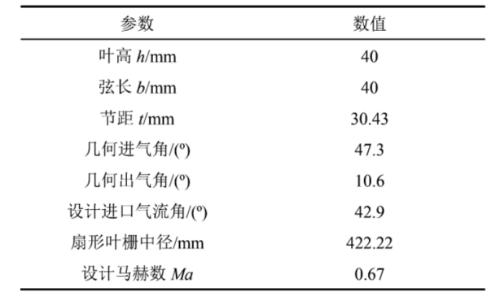
2 结束语/结论
结语中应当对整个研究的脉络作系统的梳理、分析、讨论和总结（切忌直接重复摘要和文中的内容）；说明论文研究的实用价值，以及研究工作中存在的不足、后续工作的展望等。
参考文献
- 陈继红, 杨晨, 真虹, 等. 基于随机机会约束规划的班轮联盟舱位租赁最优分配[J]. 交通运输系统工程与信息, 2018,18（1）：207-214.
CHEN J H, YANG C, ZHEN H, et al. Optimal allocation for shipping alliance slot charter based on stochastic chance constrained programming[J]. Journal of Transportation Systems Engineering and Information Technology, 2018,18（1）：207-214. (in Chinese)

